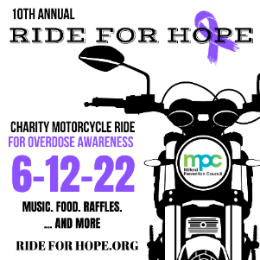
March 15, 2022

10 Years & Running - Milford Prevention Council (MPC) is once again planning our annual Ride for Hope charity motorcycle ride for the prevention of youth substance use and overdose awareness, on Sunday, June 12, 2022. This ride commemorates our 10th annual event! The Ride will begin and end at the Woodruff Family YMCA and includes lunch catered by Lasse’s Restaurant, 50/50 raffle, raffle prizes, and if all goes well…even more!

I am writing this letter to invite you to be a Sponsor of this event! If you can’t be a sponsor, a donation of a Raffle Prize would be appreciated. As a leader in the community, your involvement is an opportunity to receive exposure and to join other organizations in our community to bring awareness to substance use disorders, promote our prevention efforts, and create and strengthen community partnerships.

We are hoping to make this year amazing, and with your help, we could do just that! Enclosed is a breakdown of sponsorship levels.

As you know, MPC is a tremendous organization in the community for our youth and we sincerely appreciate your ongoing support. We look forward to a great ride! If you have any questions or concerns, please feel free to contact the MPC office at 203-783-6676 or info@milfordprevention.org.

Sincerely,

Wendy Gibbons, Director of Prevention Services | Milford Prevention Council
--------------------------------------------------------------------------------------------------------------------------------------------
Company Name (How you would like it to appear) ______________________________________________________
Contact Name____________________________________ Phone Number _________________________
Email_________________________

Sponsorship Levels ~ Please check off
Note: All Sponsors will be mentioned on the Ride for Hope website www.rideforhope.org, www.milfordprevention.org & our social media
Born to Ride Sponsorship $1,000 and above
Logo appears on two billboards 2-weeks prior to event, event banners, yard sign, event t-shirt and any other promotional materials available at time of signing. Onsite tabling presence option. Social media inclusions in event promotions. Four (4) free rider tickets included.

Cruising Sponsorship $500
Logo or Company Name appears on appropriate promotional materials available at signing, event t-shirt, yard sign, social media inclusions in event promotions. Onsite tabling presence option. Two (2) free rider tickets included
Weekend Warrior Sponsorship $250
Social media inclusions in event promotions, yard sign. One (1) free rider ticket included.

Riding For Hope Sponsor $_________ Personal Donation OR _____________________ Raffle Donation

Please make checks payable to:
Milford Prevention Council:
70 West River Street
Milford, CT. 06460

Sponsor Representative Signature__________________________________________ Date______________
(All logo sponsorships: Please e-mail your logo in a Hi Resolution format to mpccathy@gmail.com

